2020 Water Quality Reports
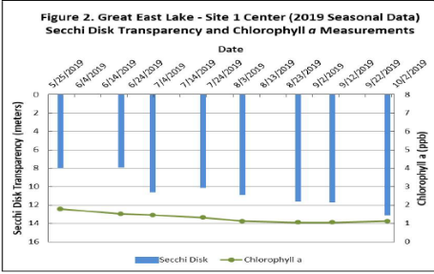
Water quality testing is the best way to understand the health of your lake. Most lakes in our area participate in some form of lake water quality sampling, but what are we testing for? And what does each parameter mean? Here is a brief breakdown of the water quality report from the UNH Lay Lakes Monitoring Program. Your lake’s report will likely have the same or mostly similar parameters. The primary parameters sampled for are:
Water Clarity: This is a simple measure of how clear your lake’s water is. Being able to see deeper is an indicator of cleaner water. The blue bars in Figures 2-3 of the attached report show how many meters down can be seen, with “0” being the surface of the water.
Chlorophyll a: This is found in the majority of plant life and is used to measure the concentration of microscopic plants in the water. Microscopic plants are an example of something that would reduce water clarity.
Total Phosphorus: Phosphorus, or “P”, is a nutrient that most directly contributes to the growth of microscopic plants and bacteria in fresh water lakes. Sources of “P” are primarily from human uses along the lake such as septic systems, pet waste, and sediment runoff from dirt roads. “P” can also be present in the lake from historic land uses such as agriculture and forestry.
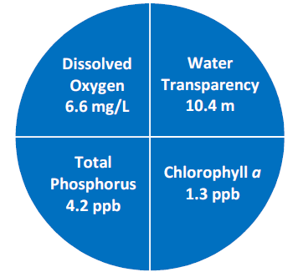
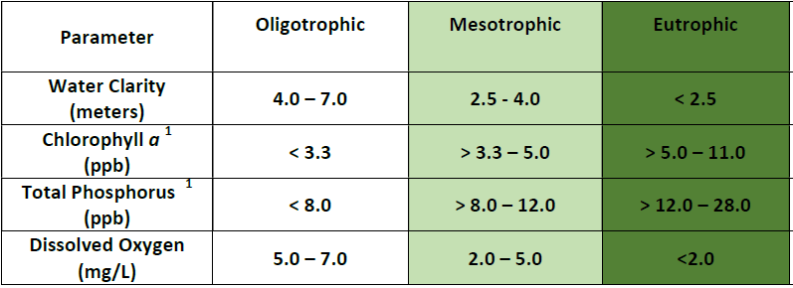
Dissolved Oxygen: “DO” is the amount of Oxygen present in the water, DO is consumed by aquatic animals such as fish, and a lake needs DO to support a healthy population of aquatic species.
Analyzing these parameters together is important because they can represent a trend. High amounts of “P” lead to an increase in plant life (Chlorophyll a). If these level spike, an algae bloom can occur and use up the oxygen, causing low DO which leads to fish kills and lower overall water quality. If all of these levels are higher than normal, the lake is considered to be nutrient rich, also known as Eutrophic. The opposite of this would be a low nutrient lake: Oligotrophic. In Table 1 of this report, it gives the range of results expected in an oligotrophic and eutrophic lake, and compares that to the sampling results. The overall trend of these parameters will determine whether your lake is Eutrophic or Oligotrophic.

The other parameter we measure for on the lake are as follows:
Color: The breaking down of soil and plants in the water can affect the color of the water, turning it the color of “tea”. This is not an indicator of water health, as much as it is an aesthetic feature of the water.
Alkalinity: This is a measure of the features in the water that make it resistant to the addition of acid into the water, such as from acid rain. In other words, high levels of “A” give the water the ability to neutralize acid. Natural sources of high alkalinity are minerals from stone such as limestone. “Hard” water is considered to have high alkalinity because of the calcium and magnesium present. So Alkalinity is sometimes used as a measurement of water hardness. Having high alkalinity in the lake is good because it protects fish and wildlife from sudden, unexpected shifts in pH.
pH – measures the amount of hydrogen ions found in a substance. On a scale from 1-14, Low pH is considered acidic (eg. citrus, battery acid) where high pH is known as basic (eg. Ammonia). Pure water has a pH of 7. We measure acidity in the water because wildlife cannot dwell in water that is too acidic or too basic. The optimal range of pH in water that is conducive to fish growth and reproduction is 6.5 – 9.0.
Specific Conductivity – This measures how easily an electric current can move through the water. Water with particulate matter (salt, phosphorus, microorganisms, etc) will increase the conductivity of the water and is an indicator of human influence in the lake. Pure water with no particulates does not conduct electricity.
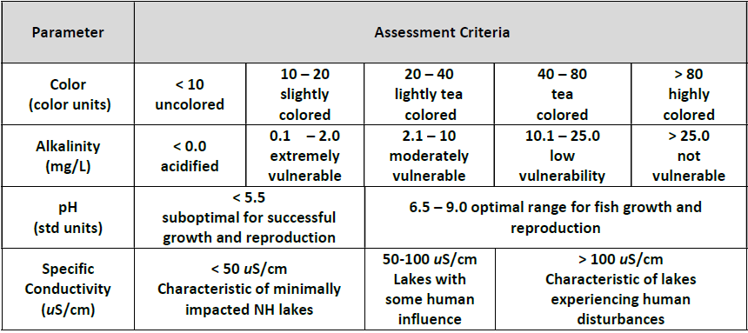
The data for these parameters is shown on graphs that compare it to previous years. This is to determine the trend of each parameter, whether it is increasing or decreasing over time. This is critical to help us understand the trajectory of the lake; what is changing and how fast it is changing.

We are grateful to all the intrepid water quality monitors that gather this data on a regular basis on each of the AWWA lakes. If you are interested in learning more about your lake’s water quality or how to get involved contact us at the AWWA office and we will get you in touch with the right group.

